NeoPixel Strand

This document describes how to assemble the NeoPixel Strand.

Inhoudsopgave
Development Environment Setup 1
ESP-01 2
Extra pins for testing 2
Operating modes 3
Arduino IDE 4
JSON (build status parsing) 10
NeoPixels 11

NeoPixels
NeoPixels are (in short) uniquely addressable RGB leds which can be chained together in large strands. Each led can be coloured and dimmed individually.
See: https://learn.adafruit.com/adafruit-neopixel-uberguide/the-magic-of-neopixels for more information.
These leds are quite handy for this project for 2 reasons:
- They have their own PWM generator inside, meaning they can be dimmed individually.
- The Arduino library for controlling these leds is quite mature, meaning we can easily integrate it in the project.
The NeoPixels come in a lot of different shapes and sizes, the ones used in the project are these:
https://www.adafruit.com/product/4356
Note: they are available in different pack sizes, take a look at the BOM where to find them more cheaply.

A word of caution
There are several instances where the user is warned about how to connect the leds. To power the leds 5V is assumed, we will use power from after the regulator, meaning 3.3V. A resistor close to the leds to prevent spikes on the data line and a large capacitor on the power supply are mentioned to prevent damage to the leds and an inrush current to cause a brown-out.
The connection schematic is adapted with these remarks in mind.

Connection schematic
The data-sheet tells us that a logic high input will be detected at a minimum voltage of 0.7 * Vcc. We connect directly to the battery, meaning the leds will be powered by 3.7V. The logic high input is the data line from the microcontroller, which is 3.3 V. Taking the formula from above: 0.7 * 3.7 = ~3.0V, this means the 3.3 V of the data line is sufficient and will be detected properly by the leds.

Schematic
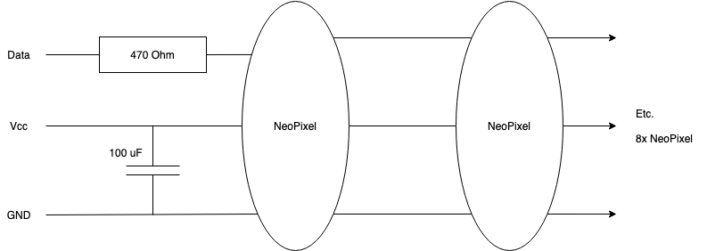
The intend is to have a strand of 8 NeoPixels in total.

Soldering
Soldering the NeoPixels is quite straightforward: with a soldering iron with a small tip, a steady hand and a little patience they are assembled without much trouble.
Each NeoPixel has a direction arrow on the back:
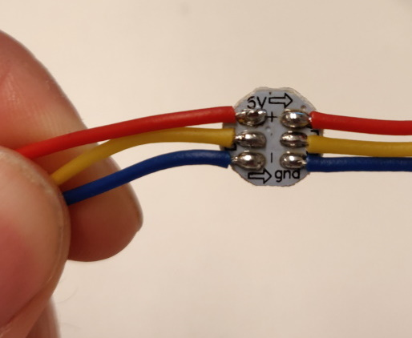
Some tips:
- Make sure the heat of the soldering iron is high.
- Try to avoid heating a soldering pad for too long, this will break the component eventually. As rule of thumb: the shorter the better.
- Put some soldering tin on the pads and wires first, before connecting them. This makes it easier to join the two.
- Do not use to much soldering tin, you really do not need that much.

After the soldering the end result will look somewhat like this:
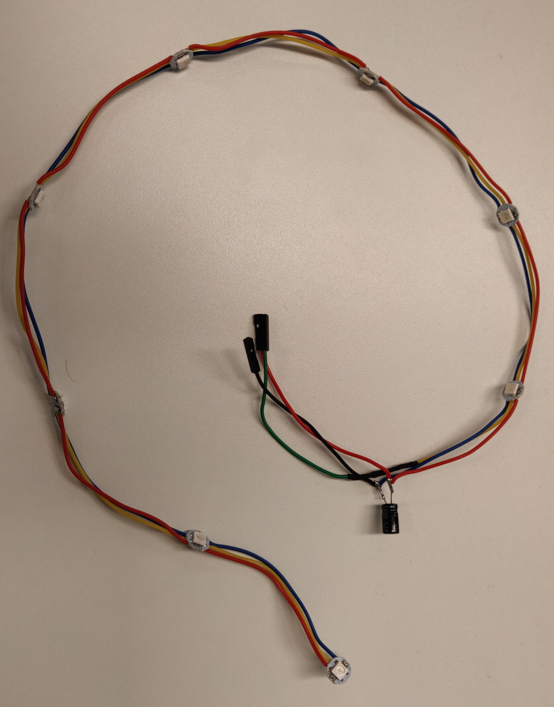
The 470 Ohm resistor is hidden under some shrink tubing in the image.

The wire ends are made of some jumper wire ends, for easier assembly in the unit later.

Some shrink tubing is used to prevent many open pieces of metal/wire.

